|  |  |
| --- | --- |
| Course Name | ITD 2313 – Script Programming |
| Instructor | Michael Schnell |
| Student Name | Joshua Crow |
| Due date | 09/27/2020 |
| Grade | <grade earned here> |
| Grading Comments | <instructor comments here> |

# Page 33

## Project # 1

### Special Instructions:

1. This project may be done in the interactive python window.  No specific code file needs to be written for this project.  Screen shots do need to show the results for all 6 of the expressions.

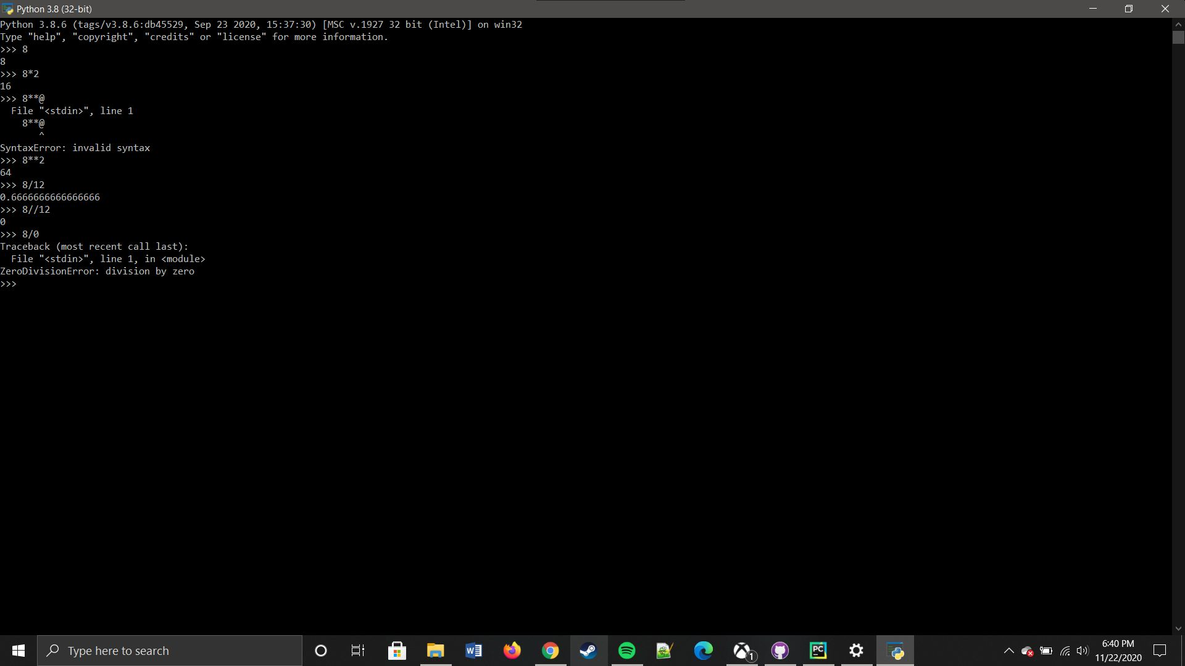

## Project # 2

### Special Instructions:

1. This project does require you write a python program.  Submit that python program as part of your submission zip file.  Call the program Project2-YourLastName

## Project # 3

### Special Instructions:

1. This project is done in the interactive python window.

* Specific Test data:
* In the instructions where is says to assign name an appropriate value.  Assign name the value of Pistol Pete.

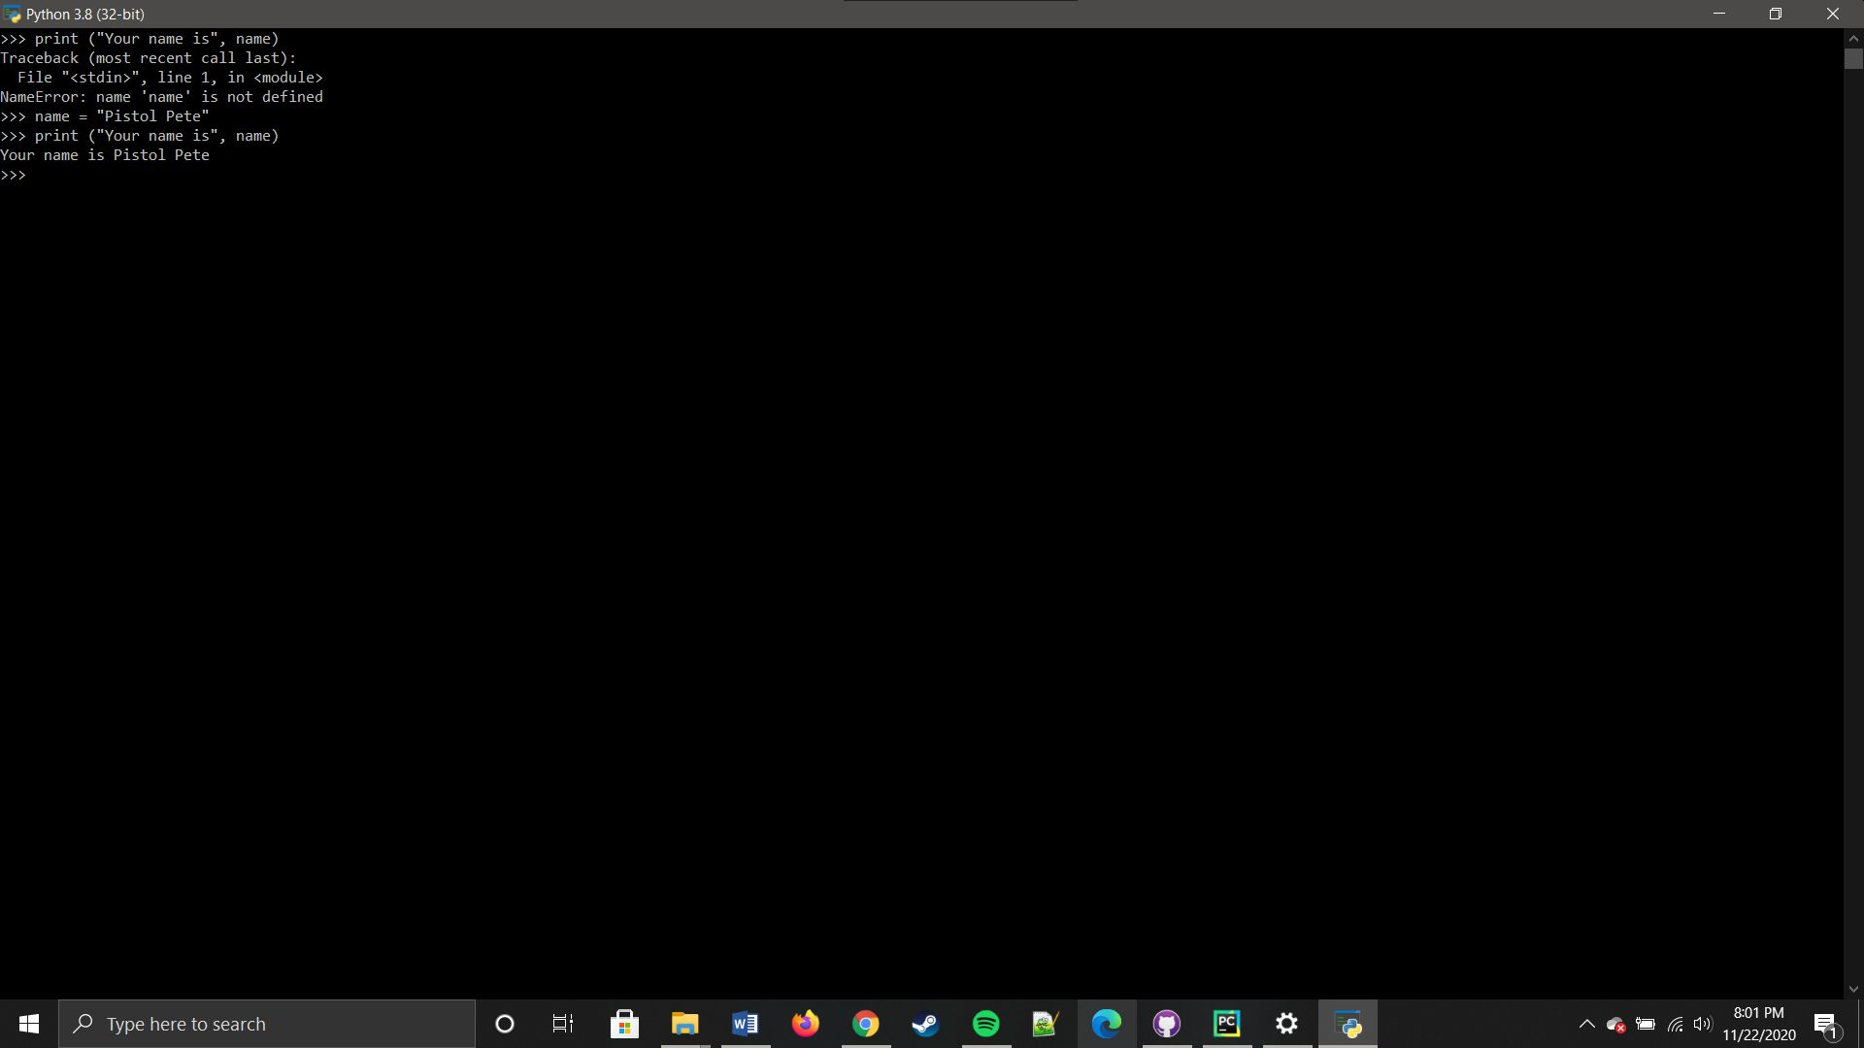

## Project # 4

### Special Instructions:

1. This project does require you to create a python program file.  Be sure to include that file in the zip file when submitting the assignment.

* Specific Test data:
* Instructions say to run it 3 times.  As it is a rectangle, your three test data sets are:  Run 1 - Length 10  Width 3,  Run 2 - Length 7 With 13, Run 3 - Length 6 Width 6

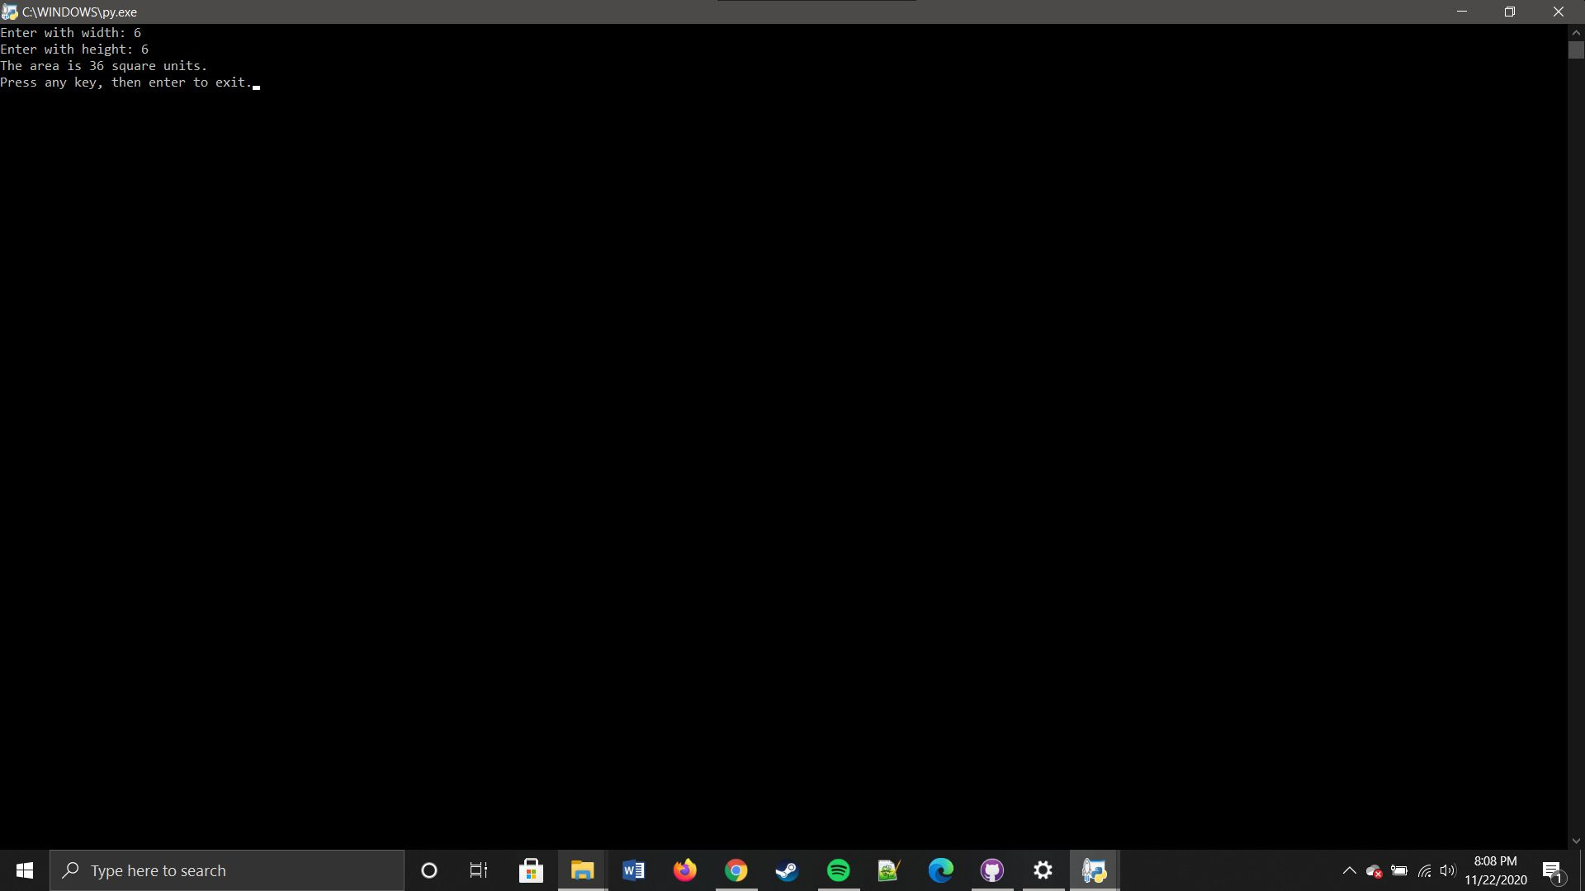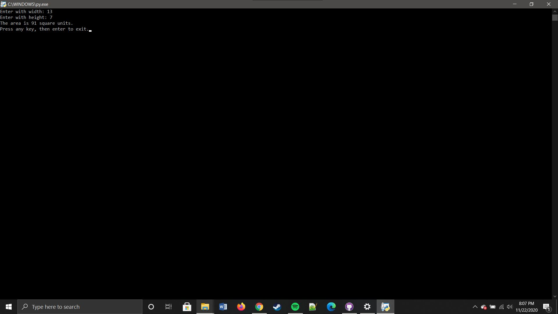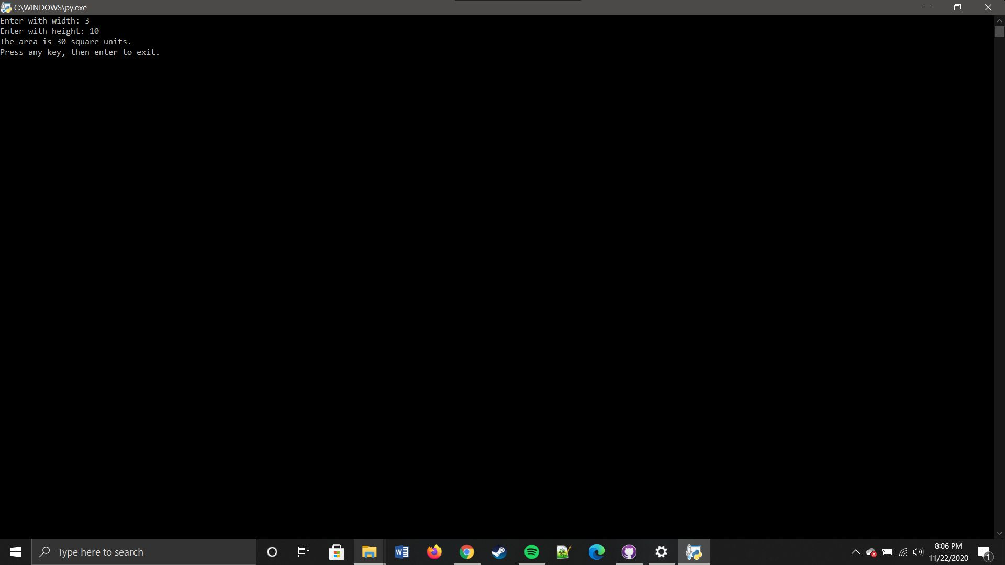

## Project # 5

### Special Instructions:

1. This project requires that you write a python program.  Be Sure to include that file in the zip file when submitting the assignment.

* Specific Test data:
* You are to run this one 3 times also.  Use the following Base and Height pairs for those three runs.  Run 1 - Base 5  Height 7, Run 2 - Base 6 Height 5, Run 3 - Base 10 Height 10

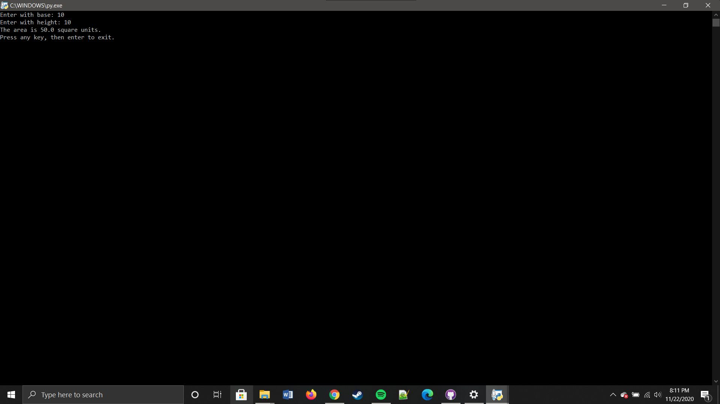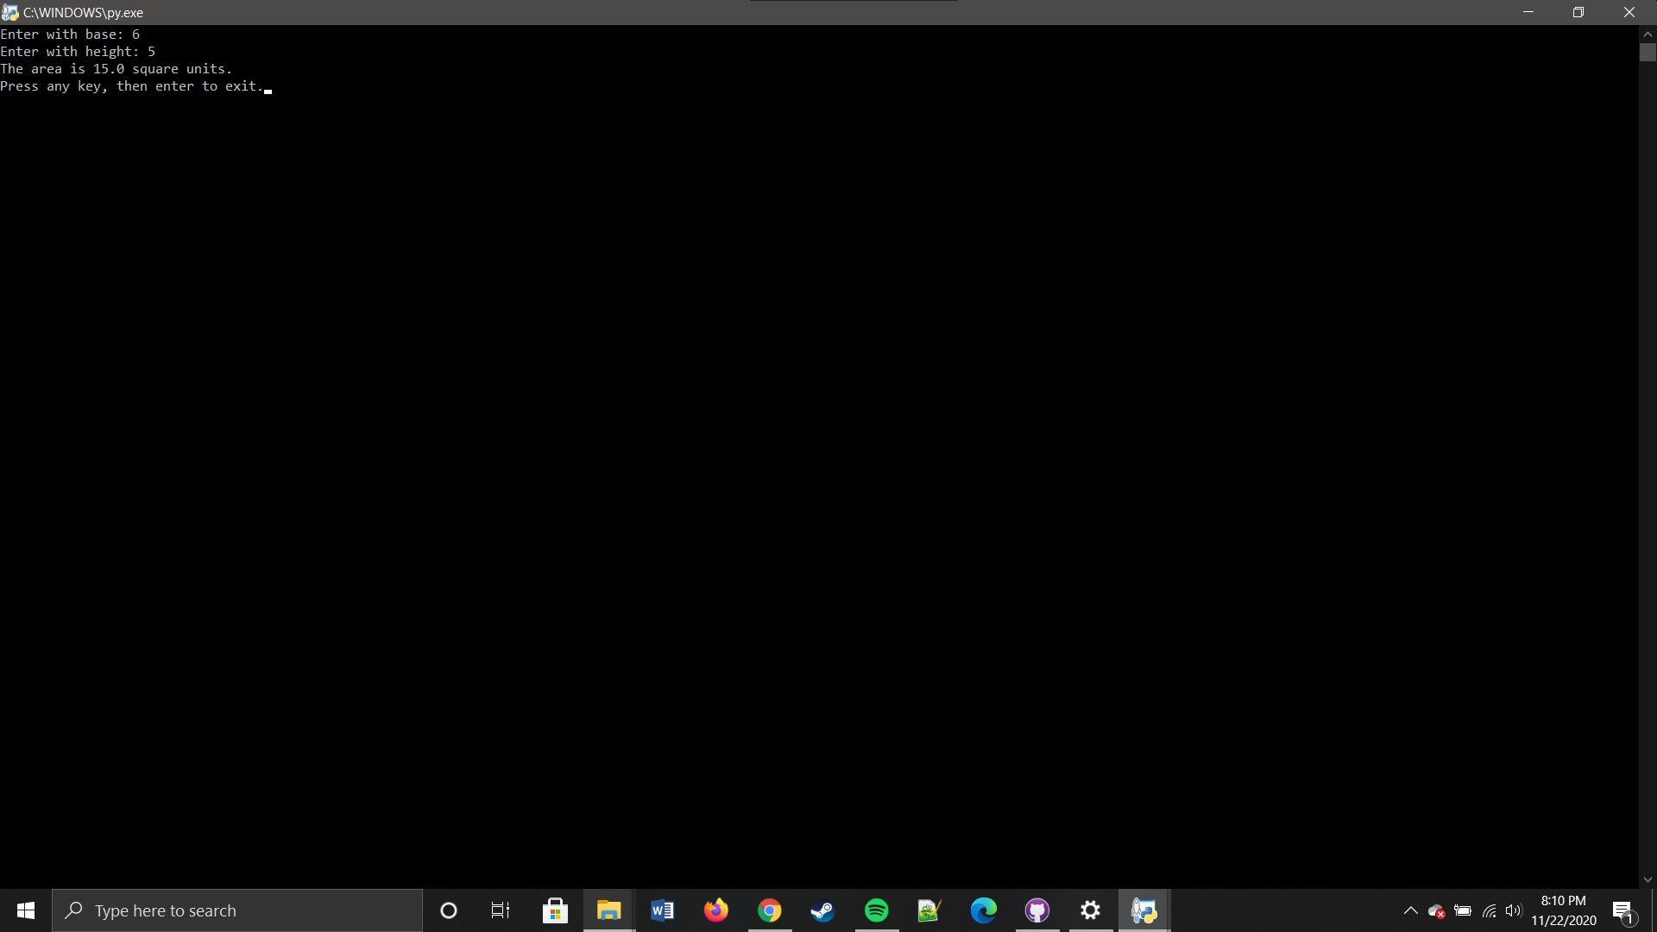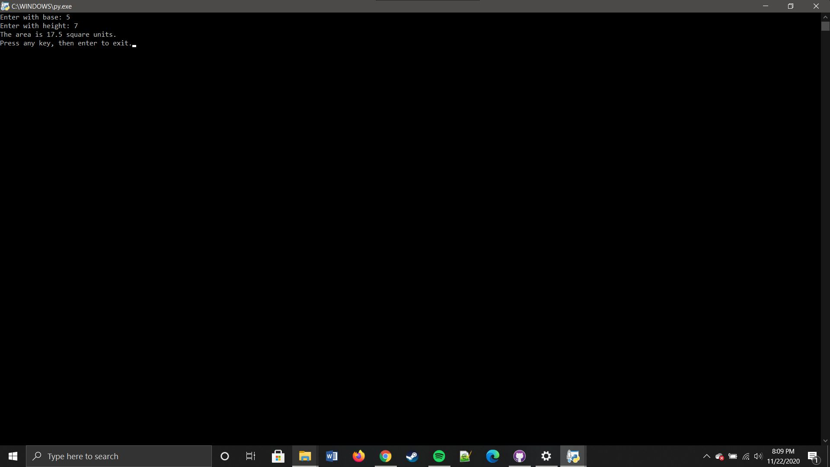

## Project # 6

### Special Instructions:

1. This project requires that you write a python program.  Be Sure to include that file in the zip file when submitting the assignment.

* Specific Test data:
* You are to run this one 3 times also.  Use the following values for Radius in each of the runs:  Run 1 - 7, Run 2 - 6.31, Run 3 14.96.

You have made it to the end of this projects assignment.  The screen shots you took should be in the Submission document.  Any and all code written will need to part of the overall submission to the drop box. Place all code and the submission document into a single ZIP file and submit that zip file to the dropbox.

